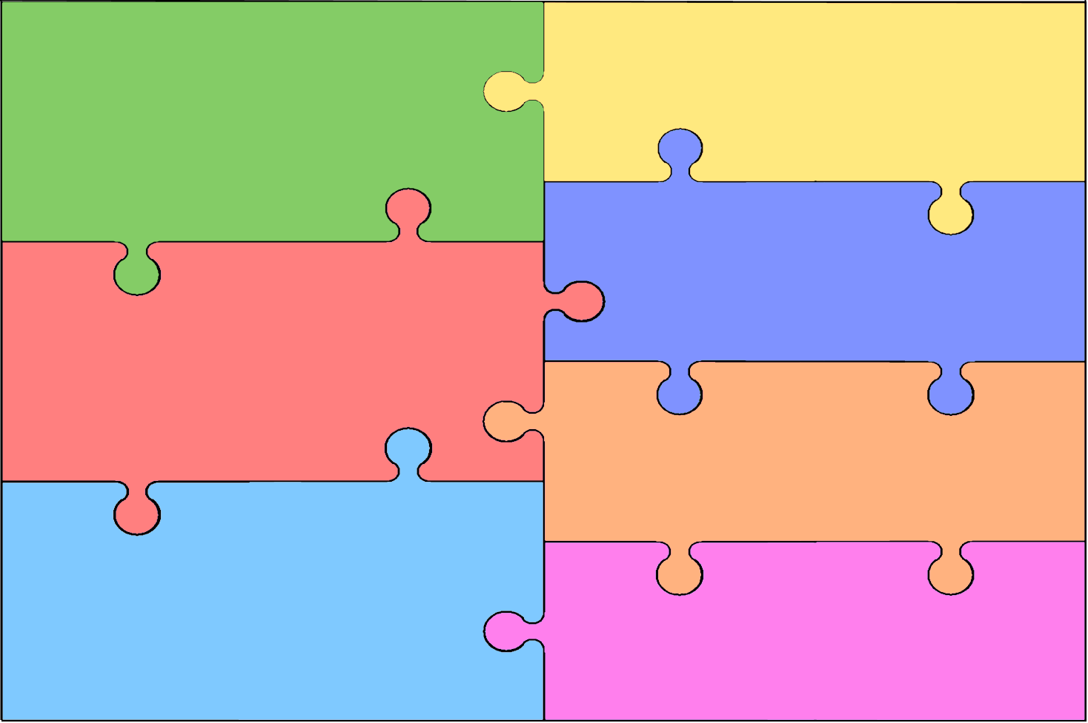
Curriculum Overview for Early Years Foundation Stage (How many colours in a rainbow? and Are eggs alive?)
Personal, Social & Emotional Development  - Expresses own preferences and interests.  - Can select and use activities and resources with help.  - Seeks out others to share experiences.  - Shows affection and concern for people who are special to them. | Literacy  - Listens to stories with increasing attention and recall.  - Describes main story settings, events and principal characters.  - Enjoys rhyming and rhythmic activities.  - Shows awareness of rhyme and alliteration.  - Joins in with repeated ref rains and anticipates key events and phrases in rhymes and stories.
Mathematics
- Realises not only objects, but anything can be counted, including steps, claps or jumps.
- Knows that numbers identify how many objects are in a set.
- Uses some number names and number language spontaneously.
- Uses some number names accurately in play.
- Shows interest in shape by sustained construction activity or by talking about shapes or arrangements.
Communication & Language

- Is able to follow directions (if not intently focused on own choice of activity).
- Responds to simple instructions, e.g. to take or put back an object.
- Builds up vocabulary that reflects the breadth of their experiences.
- Listens to stories with increasing attention and recall.
- Beginning to use more complex sentences to link thoughts e.g. (‘I want to use strawberries because I like them.’)
Understand the World
- Can talk about some of the things they have observed such as plants, animals, natural and found objects.
- Recognises and describes special events for family or friends.
- Developing an understanding of growth, decay and changes over time.
- Talks about why things happen and how things work.

Expressive Arts & Design
- Uses various construction materials.
- Sings a few familiar songs.
- Explores and learns how sounds can be changed.
- Notices what adults do, imitating what is observed and then doing it spontaneously when the adult is not there.
- Explores colour and how colours can be changed.
Physical Development

- Draws lines and circles using gross motor movements.
- Uses one-handed tools and equipment.
- Holds pencil near point between first two fingers and thumb and uses it with good control.

