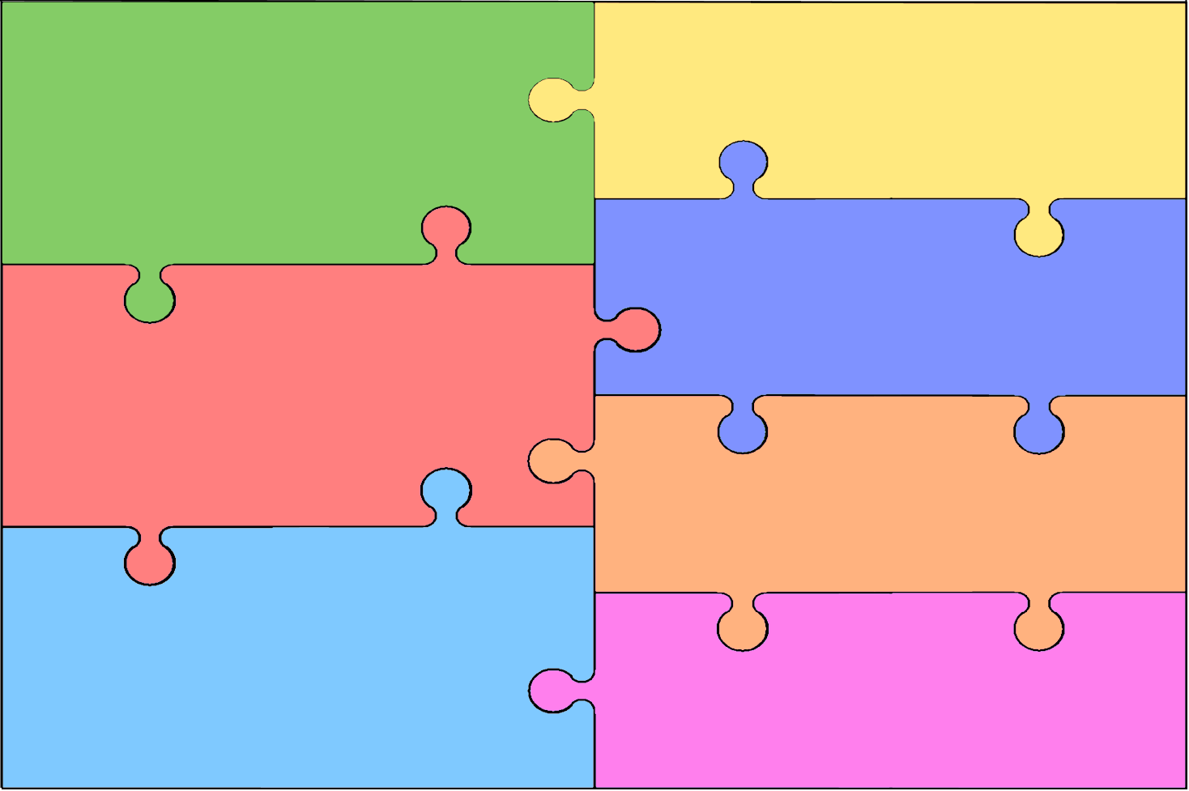
Curriculum Overview for Early Years Foundation Stage (Can I switch it on? ) (Why do lady birds have spots?)
Personal, Social & Emotional Development  - Enjoys responsibility of carrying out small tasks.  - Confident to speak to others about own needs, wants, interests and opinions.  - Say why they like some activities more than others.  - Be resourceful in finding support when they need help or information  Communication & Language | Literacy  - Sometimes gives meaning to marks as they draw and paint.  - Hears and says the initial sound in words.  - Writes own name and other things such as labels, captions.  - Attempts to write short sentences in meaningful contexts.  - Can segment the sounds in simple words and blend them together.  - Listens to and joins in with stories and poems, one-to-one and also in small groups.  - Beginning to be aware of the way stories are structured.  - Suggests how the story might end.  - Listens to stories with increasing attention and recall.
Mathematics
- Shows an interest in shape and space by playing with shapes or making arrangements with objects.
- Uses familiar objects and common shapes to create and recreate patterns and build models.
- Selects the correct numeral to represent 1 to 5, then 1 to 10 objects.
- Finds one more or one less from a group of up to five objects, then ten objects.
- In practical activities and discussion, beginning to use the vocabulary involved in adding and subtracting.
- Orders and sequences familiar events.

Understand the World
- Joins in with repeated refrains and anticipates key events and phrases in rhymes and stories.
- Two-channelled attention – can listen and do for short span.
- Respond to what they hear with relevant comments.
- Beginning to understand ‘why’ and ‘how’ questions.
- Listens and responds to ideas expressed by others in conversation or discussion.
- Answer ‘why’ questions about their experiences and in response to events.
Physical Development

- Mounts stairs, steps or climbing equipment using alternate feet.
- Walks downstairs, two feet to each step while carrying a small object.
- Uses one-handed tools and equipment, e.g. makes snips in paper with child scissors.
- Travels with confidence and skill around, under, over and through balancing and climbing equipment.
- Uses a pencil and holds it effectively to form recognisable letters, most of which are correctly formed.
- Shows some understanding that good practices with regard to exercise, eating, sleeping and hygiene can contribute to good health
- Can talk about some of the things they have observed such as plants, animals, natural and found objects.
- Developing an understanding of growth, decay and changes over time.
- Looks closely at similarities, differences, patterns and change.
- Completes a simple program on a computer.
- Uses ICT hardware to interact with age-appropriate computer software.
- Knows some of the things that make them unique, and can talk about some of the similarities and differences in relation to friends or family.
Expressive Arts & Design
- Explores colour and how colours can be changed.
- Understands that different media can be combined to create new effects.
- Engages in imaginative role-play based on own first-hand experiences.
- Chooses particular colours to use for a purpose.
- Beginning to construct, stacking blocks vertically and horizontally, making enclosures and creating spaces.
- Experiments to create different textures.
- Introduces a storyline or narrative into their play.

